**EMBEDDED SYSTEMS AT HOME:WASHING MACHINE**

**Definition:** Embedded systems is defined as a system that has software embedded into computer hardware,which makes the system dedicated for certain application.

**Principle of Washing Machine:** Washing machines are most commonly used electronic home appliance. Now a days most of the washing machines are fully automated which wash clothes according to thier type and degree of dirt on them. The modern washing machines contains microcontrollers with sufficient memory and keyboard,display etc facilities. These automated devices decide wash cycle, water temperature, wash modes, wash times on thier own depending upon clothes.

**Block Diagram:**

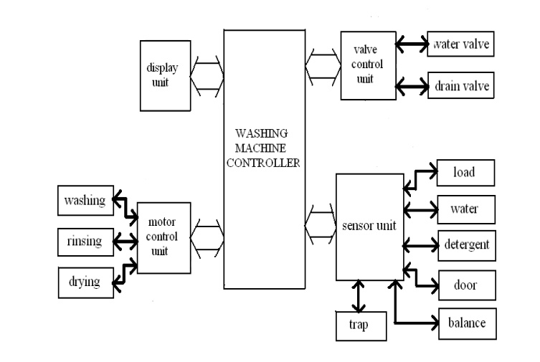

Washing machine consists different modules for the interaction between software and hardware components like

* LCD or LED displays for displaying the program and control touch panel ,
* Keypads for program entry,
* Driver Motor which can rotate in two directions during washing,
* Water pump for reciculating water and dump out dirty water,
* Different sensors for checking water level, water temperature ,for controlling water flow, Observing door position whether it is open or closed etc
* Some selection knobs for selecting spin speed, water temperature, wash time, load size, type of wash required for clothes
* Inverter unit empowers the machine to run at its optimum speed based on how much is loaded into the machine.
* System controller controls the motor speed at different phases like washing , rinsing ,drying and some sensors like door sensor,pressure sensor,speed sensor are also maintained by this.